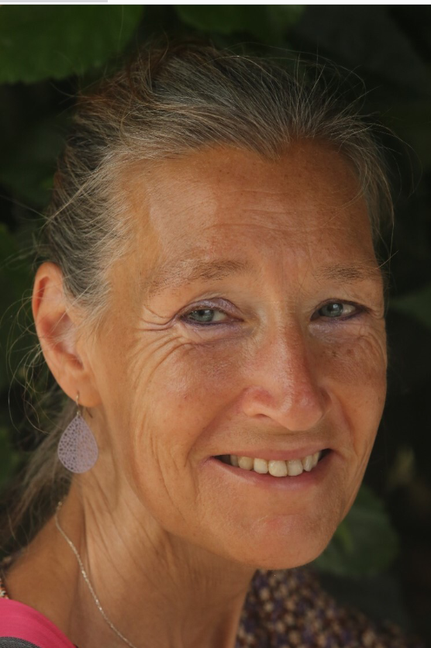
Hanneke van Kooten
December 12th 1961 – January 12th 2023
On January 12th of this year, we received the message that our committee member, member of the Global Advisor Council (ICPAN) and chairwoman of the organizing committee of ICPAN Amsterdam 2023, had passed away. We knew she had been ill for quite some time. Despite her illness, she devoted herself to the very end to the ICPAN conference 2023.

Hanneke worked as a recovery nurse at the Martini Hospital in Groningen since 2008. There she was responsible for the implementation of the ERAS protocol. Outside of work, she devoted herself with heart and soul to the BRV at the Committee on Congresses, the Waking Up and ICPAN. For the Waking Up she wrote several articles about EBP and later wrote updates about the international conferences by ICPAN and the Global Advisory Council. She was also a contact person from the BRV for ICPAN in the Global Advisory Council for many years, in which a representative from each participating country advises the board of ICPAN. Having lived in the United States for several years, Hanneke was fluent in English which served her well at ICPAN. She organized with ease various activities during the ICPAN conferences throughout the years. During the conference in Denmark, she was involved in the scientific program and acted as chairperson during the various sessions with speakers.

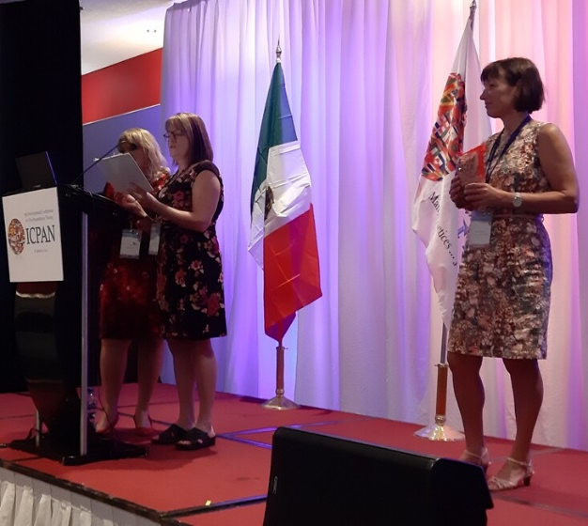
In Sydney 2017, she gave a presentation about ERAS with her colleagues (anesthetist and anaesthesiologist). Two years later, in Cancun 2019, she was (again) jointly responsible for assessing the content related contributions.
After we decided to bring the international congress to the Netherlands for 2023, it became obvious that Hanneke would play a major role and she devoted herself wholeheartedly to this conference.

The local organizing committee together with Hanneke planned and designed the conference and her view and input was crucial. Thanks to her dedication, we are sure that it will be a great conference intertwined with her personal and professional spirit.
A few weeks before her death, she recorded a welcome speech at the Martini Hospital, which will be screened at the opening of ICPAN 2023. It may be difficult for the local organizing committee, the ICPAN board members and you as participants to watch, but it was her greatest wish for this conference to be a success. By showing her video Hanneke can play an integral part of the conference opening even if she is no longer with us.
In Hanneke we have lost a very passionate recovery nurse and colleague, knowledge, skills and ideas, but also a loving and kind person who touched peoples hearts. We miss her very much. We wish her husband Theo, her children and grandchildren a lot of strength for the future

